CP LAB Git & GitHub Fundamentals ASSIGNMENT

Name: Abdur Rehman Siddiqui
SP26-BSAI-0023 – AM Section

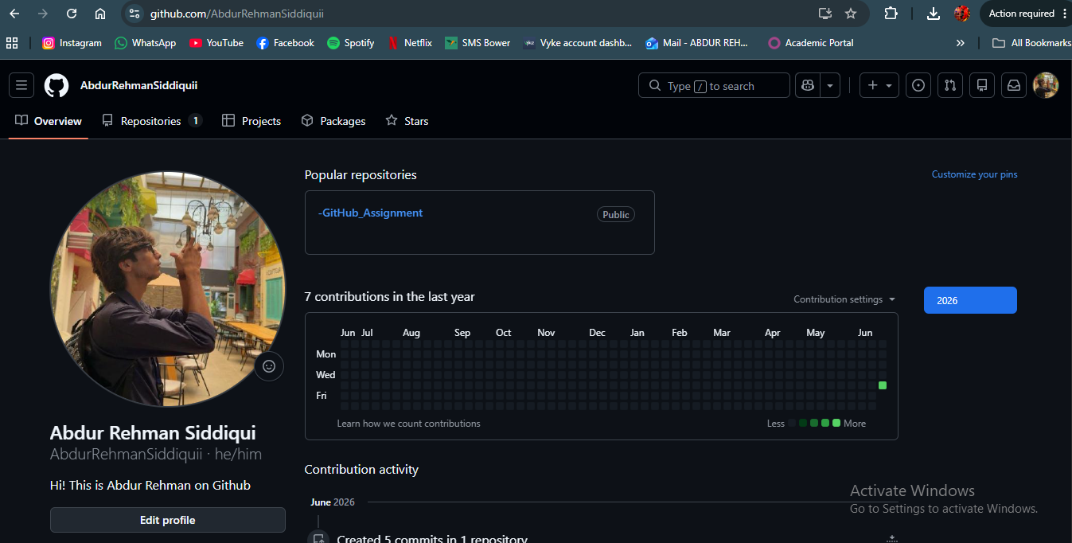
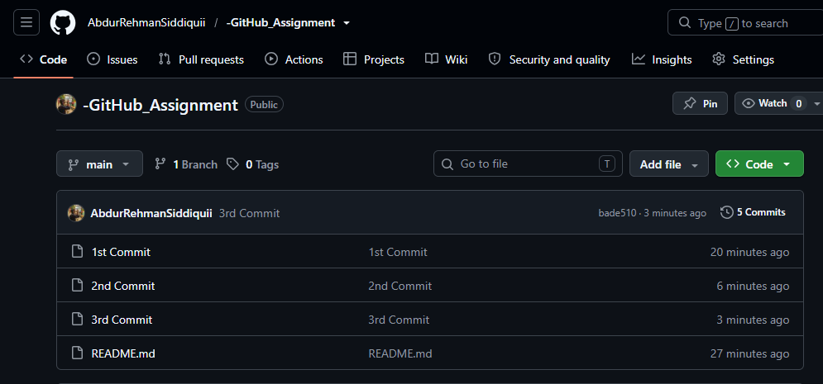

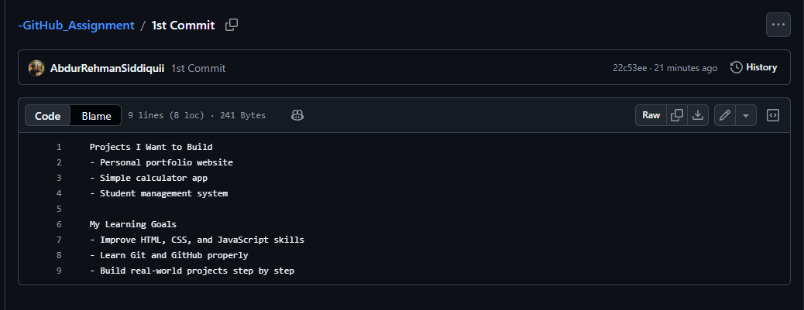
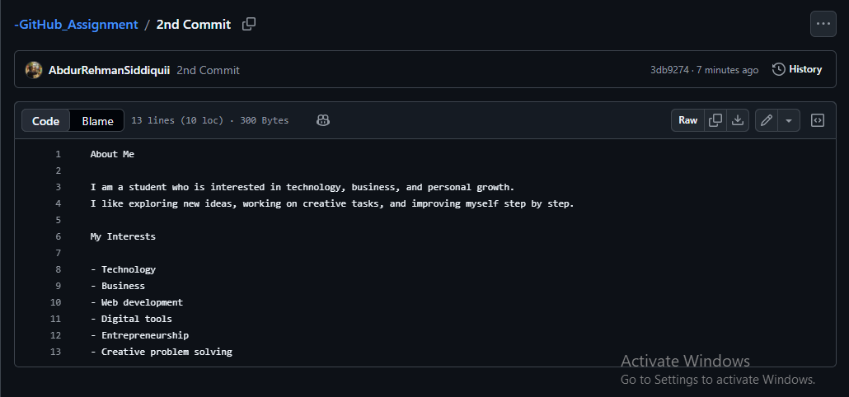
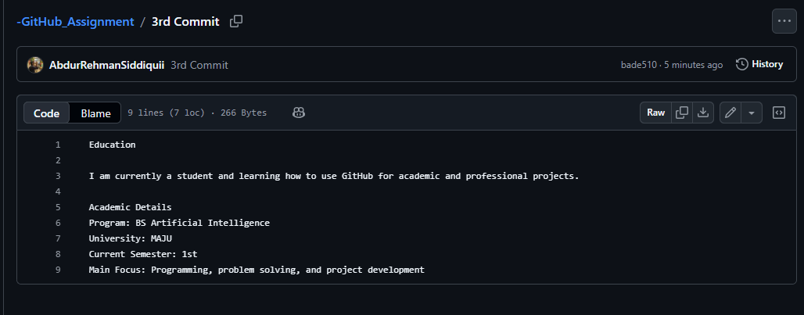

https://github.com/AbdurRehmanSiddiquii/-GitHub_Assignment

